iRest API Tryout

# Goals & Objectives

We want to implement the an option for the iRest APIs which helps existing users to check the output of API without dependency of 3rd party API render tool such as postman. With this feature we can provide the option to test all the project API Documentation with [Open Specifications](https://en.wikipedia.org/wiki/Open_specifications) validation within iRest without going for external tools such as Swagger.io.

# Tryout Journey

1. User should be start from a Login Screen.
2. After successful login, User would be redirected to Mock List Page where Mock List should have Pagination and Sorting options.
3. User could see an option for Tryout on the Mock List Dashboard. Once Clicked one Modal will open up which contains the UI for API Simulation with <RapiDoc> (<https://github.com/mrin9/RapiDoc> ). See the screenshot below for popup UI.

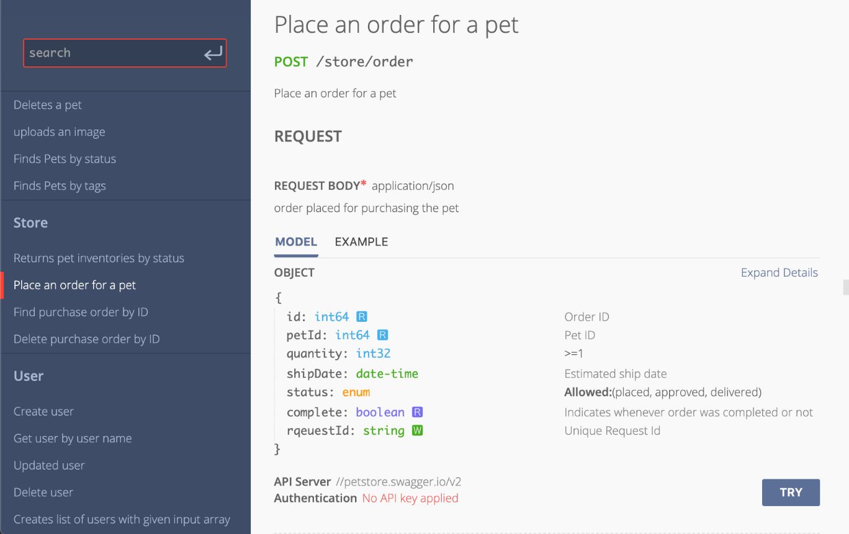

1. In the left navigation user should be able to see the list of all available mocks per project basis. (Ignore the search option in screenshot.). By default 1st Item from the left has been rendered with all available request option. When User hits “TRY”. The backend API should be called and user will get the API response from iRest API.
2. When user click on any other item in the list on left hand side will replace the right hand side option and render the request section of that particular mock. See [this](https://mrin9.github.io/RapiDoc/examples/focused-mode.html#overview) example for reference.

# Requirements

1. User should be able to tryout multiple APIs at once from iRest Mock List Dashboard.
2. User must have the option to switch the one mock to another to get the response from iRest Simulator.
3. We does not require any search or local JSON option. Remove the option since it’s not useful.

# Story Breakdown

1. Export & Convert the Mock List Data to Open Specifications JSON Structure.
2. Allow RapiDoc to utilize converted Open Specifications JSON Structure and render Swagger UI List and Tryout Option from the specifications.
3. RapiDoc – Swagger UI try option within Tryout Modal.

# References

1. Open Specification 3.0: <https://swagger.io/specification/>
2. RapiDoc: <https://github.com/mrin9/RapiDoc>